1. INTRODUCTION:
   1. Overview:

Our Team Project is FASHION HAVEN. In our Fashion Haven we have a chic, stylish and affordable clothing store for women, men and also for kids. A fashion trend signifies a specific look or expression that is spread across a population at a specific time and place. A trend is considered a more ephemeral look, not defined by the seasons when collections are released by the fashion industry.Fashion Haven is a private limited company also registered under GST in Tamil Nadu.

* 1. Purpose:

Fashion Haven makes us feel more authoritative and professional.

are influenced by several factors like cinema, celebrities, innovations. In Fashion Haven, customers should need to have an idea of what you are looking for before you start shopping, whether that’s in store or online. Clothes influence how we look at someone.

1. Proplem Definition & Design Thinking:
   1. Empathy Map:

In the Empathy Map we describes what we feels, says, think and does about the topic ‘Fashion Haven’.

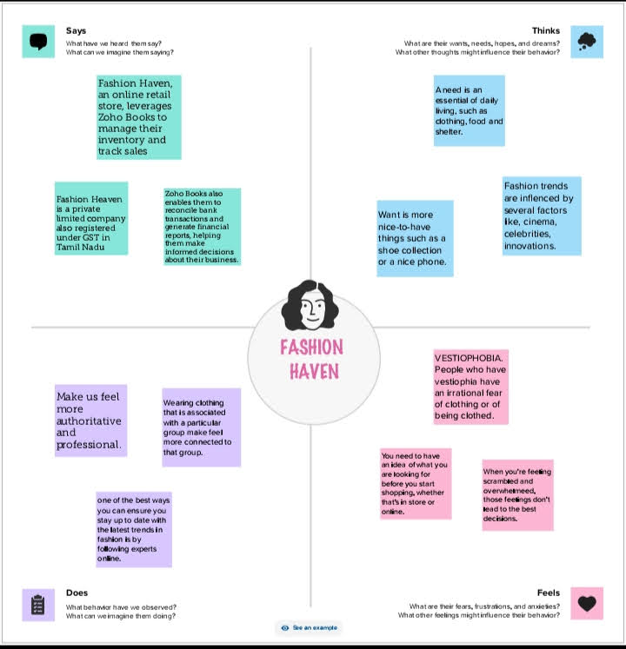

* 1. Ideation & Brainstorming Map:

In Ideation and Brainstorming Map, We excludes our ideation in the Brainstroming.

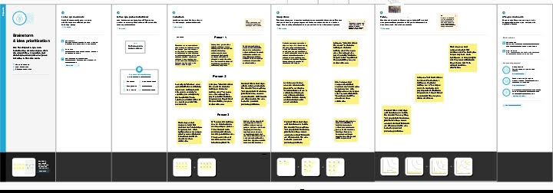

1. RESULT:

The final output of the project we found that the profit & loss had been loss in our books. 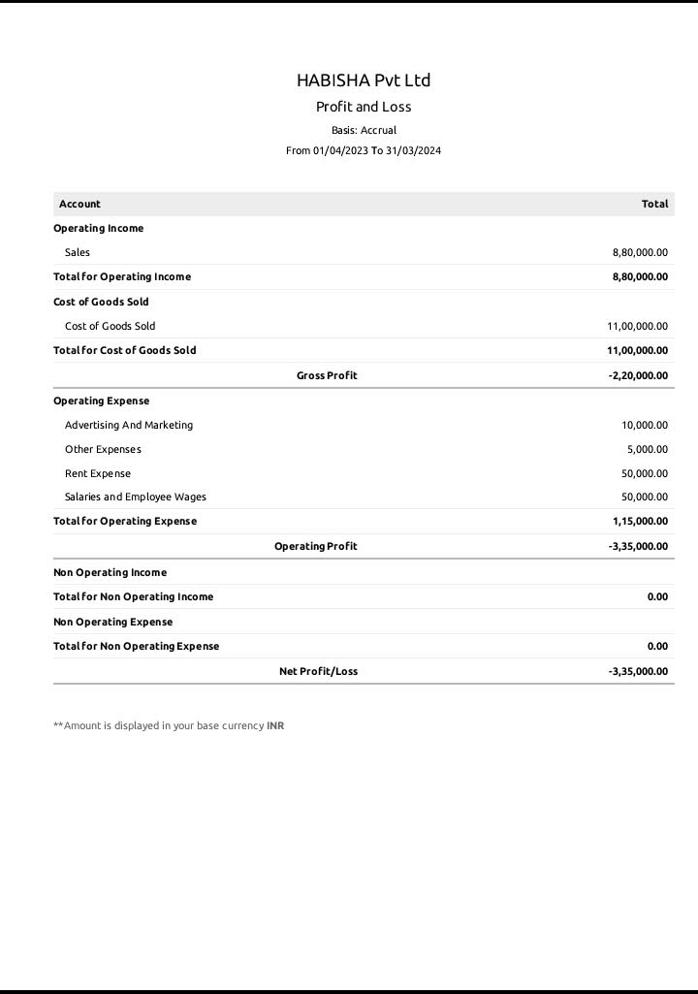

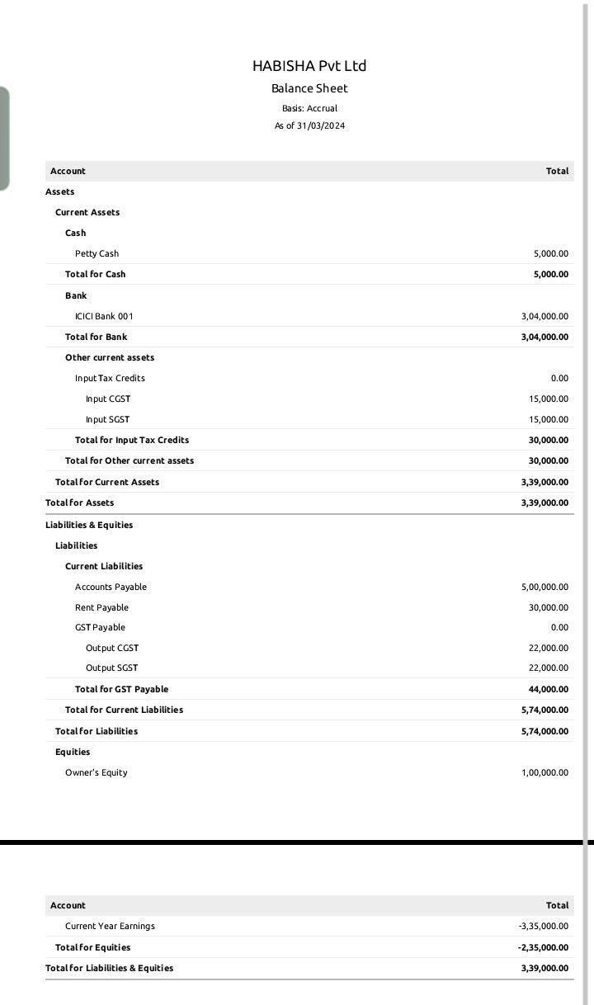

1. ADVANTAGES

Fashion trends can influence individuals to develop their unique style. Individuals can experiment with various styles and convey themselves creatively. Following fashion trends can enhance one's self-confidence because it fosters a sense of belonging and social acceptance. This confidence can result in increased self-esteem and a favorable self-image.

DISADVANTAGES:

 Fashion trends can create social pressure to conform, leading to a lack of individuality and self-expression.  Some trends may not be inclusive of all body types, leading to body image issues and self-esteem issues.

1. APPLICATION:

E-Commerce and Retail industry

1. CONCLUSION:

Overall, In Fashion Haven we excludes our feel, does, says and think of the topic. Then we executes our ideas about Fashion Haven. Finally, we created Accounting books of Fashion Haven and also submitted the reports of results.

1. FUTURE SCOPE:

Upon completion of their specialized studies in fashion design, students can have an abundance of opportunities in this industry. They can find employment in different sectors such as fashion industry, manufacturing and exporting units, or start their own business and sell their products on the market.